A bried user guide for pyPEDM
Follow these steps to configure your system and run the pyPEDM (pyPEDM_demo.py) for processing LA-ICPMS fission track data. See Tian and Zhong (2026, G-cubed) for methodology. Please kindly let me know, when noticing bugs.

1. Install IsoplotR for R
- Install the IsoplotR package of Vermeesch (2018) in R. Detailed installation guides are available on the website: https://isoplotr.es.ucl.ac.uk

2. Configure the R Environment in Python
The Python script needs to locate your R installation. Set the R_HOME environment variable accordingly.
- On macOS/Linux:
This is typically handled automatically. If needed, you can use os.environ in Python. Below is an example:
import os
# Usually not required, but can be set if R is not found
# os.environ['R_HOME'] = '/Library/Frameworks/R.framework/Resources'

- On Windows:
Explicitly point to your R installation directory. Adjust the path to match your specific R version. Below is an example:
import os
os.environ['R_HOME'] = r'C:\Program Files\R\R-4.5.0' # Update version number as needed

3. Install Required Python Packages & Run the Script
- The script main_data_processing_demo_data.py requires several Python dependencies.
- The simplest method is to run the script first. It will fail with clear ModuleNotFoundError messages indicating which packages are missing.
- Install each missing package using pip (e.g., pip install pandas rpy2 numpy).
- Once all dependencies are installed, run the script again. You can use any preferred code editor (e.g., Visual Studio Code, Spyder, PyCharm) or execute it from the terminal/command line.

4. Running the Script and Setting Parameters
If the script runs successfully, a configuration window will open. Follow these steps to set the required processing parameters.
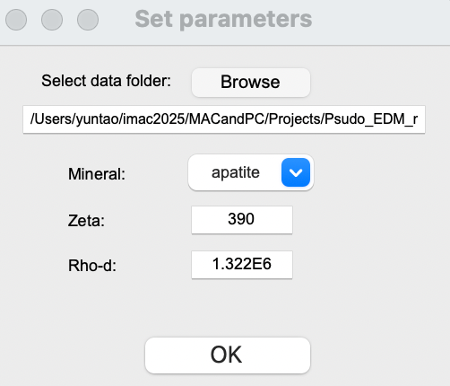
a. Select the Data Directory
- Browse to and select the folder containing your LA-ICP-MS fission track data files.
- These files must be formatted according to the provided template.
- This directory will be used for input and will also contain the output files, including radial plots, and a excel file compiling the calculated ages, and associated statistics.
b. Choose the Target Mineral
- From the dropdown menu, select the mineral you are analyzing (apatite or zircon). This selection influences default values and calculations.
c. Input Calibration Constants
- Enter appropriate values for the zeta (ζ) constant and the dosimeter track density (ρ_{d}) to calculate the number of pseudo-induced tracks (N_{ni}) via the pseudo-EDM approach.
- Recommended typical ranges:
  - For Apatite:
    - Zeta (ζ): 330 – 400
    - ρ_{d} (using CN2 glass): 0.8E6 – 1.8E6 cm⁻²
  - For Zircon:
    - Zeta (ζ): 100 – 130
    - ρ_{d} (using CN1 glass): 0.1E6 – 1.0E6 cm⁻²
d. Execute the Processing
- Click OK to start the analysis.
- The code will automatically process all qualifying sample files within the selected directory and generate the corresponding output.

5. Output Files and Plot Customization
After processing is complete, the script will generate the following outputs for each sample in your selected directory:
- Two Radial Plots for each sample: one is using the traditional LA-ICPMS equations and the other using the pseudo-EDM approach (with a postfix _pseudoEDM.png).
- A Single Excel File (ages_results.xlsx) that compiles the calculated ages and relevant statistics (e.g., pooled age, central age, dispersion, chi-square test results, p-values etc) for all processed samples.

6. Customizing the Radial Plots
You can modify the appearance and quality of the generated radial plots by editing specific parameters in the plotting section of the script.
- Basic Plot Appearance:
Look for the line containing isoplotR.radialplot()—typically resembling isoplotR.radialplot(x=data, oerr=1). Adjust the arguments within this function call (e.g., oerr, show.numbers, pch) to change visual elements.
- Adjusting Plot Size and Resolution:
To increase the resolution and dimensions of the saved plot images, locate and increase the values for these parameters before the plot generation:
radialplot_width = 500 # Default: 300 (width in pixels)
radialplot_height = 500 # Default: 300 (height in pixels)
radialplot_res = 150 # Default: 100 (resolution in DPI)
Higher values will produce larger, higher-resolution image files but may increase processing time and file size. Adjust these values to suit your publication or display requirements.

